1. OSSEC GUI screenshot showing the log alerts produced by the three events generated under section 2. (10 points per event)

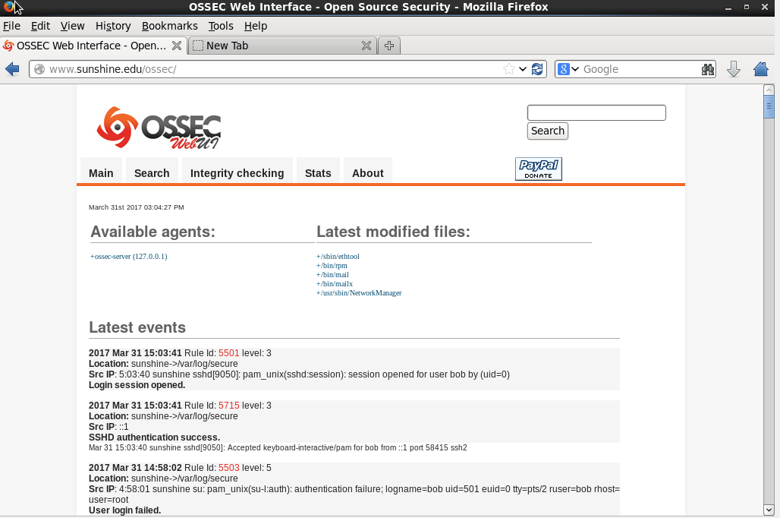

1. OSSEC GUI screenshot showing the integrity check for the file which you have altered. (20 points)

